K-12 Digital Resources to Support Student Learning at Home
We are continuing to add to and update our list of digital resources to support student learning at home.
The majority of the educational applications listed below can be accessed through the Clever Portal. The programs that are accessed through the listed websites are marked by an asterisk. Students are able to log in to Clever from home or school using their studentnumber@columbus.k12.oh.us as username and birth date with dashes as password (MM-DD-YYYY).
If you are new to Clever please follow this link  instructional document to find instructions for logging in to the Clever Portal. If you need help with access during the school closure, use this link to submit a help ticket: https://support.clever.com/hc/en-us (7am-8pm).

Resource Name with Application Icon you would see on Clever | Description of Digital Resource | Grade and Discipline | Tutorial Documents and/or Videos
Start Here   | Provides access to students and teachers to learning applications provided by Columbus City Schools. | Each student and teacher dashboard is personalized with the applications provided for that individual, Pk-12 | Clever  Once on your dashboard, click on the icon for the application below to access the District resource.
Advanced Placement (AP)   | This site provides information and updates from the College Board regarding Advanced Placement Courses, Online Practices and Information about AP Testing | High School - Various content areas | https://apcentral.collegeboard.org/about-ap/news-changes/coronavirus-update
Achieve3000   | Contains informational texts for students to read and questions to answer.  Students with licenses can access through Clever. Lexile scores will continue to adjust based on Activities completed. | ELA, Science, Social Studies-Grades 6-9 (sign on to account through Clever)  Students without licenses use the Literacy at Home link. | Achieve3000 Supports  Printable pdfs for  grades 2-12  Literacy at Home  (Grades 2-12 without activeDistrict-provided licenses)
ALEKS & ConnectED  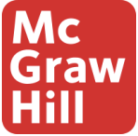 | This is an individualized math platform. Students will need to be given their usernames and passwords by their teacher. | Math  ALEKS 3-12  ConnectEd K - 12 (via Clever) | https://tinyurl.com/CCS-MH-Support  McGraw Hill CCS Math Extended Learning Hub
*BookFlix   | Paired fiction and nonfiction popular texts that engage readers and support literacy. Helps students build foundational skills through making connections, building background knowledge, and building vocabulary. Read aloud feature can be disabled as readers progress. Lexile reading levels included. | Reading PreK-3 | https://bookflix.digital.scholastic.com/home?authCtx=U.600011295
CommonLit   | Contains literary and informational texts for students to read and questions to answer.  Access through Clever | ELA, Science, Social Studies-Grades 3-12 | Parent Instructional Video  CommonLit Student Tutorial  CommonLit General Video Tutorial  -If students do not have assigned readings, they can click on the Library Tab in the top, left corner to make selections.
DBQ Project   | Contains linked informational and literary readings that culminate in a longer writing. Social Studies DBQs and English Literature MiniQs are available. | ELA & Social Studies-Grades 6-12 | Lessons only available if assigned by the teacher.  Student Directions  Teacher Directions
Duolingo 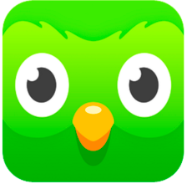 | This is a language learning app. It provides language lessons/practice in most languages taught in CCS. | Spanish, French, Italian, Japanese, Chinese, Latin, Korean, English (for EL’s) | Log in using your username and password or sign up for a new account if you are new to Duolingo, then just choose a language.
Edmentum Courseware/Plato  | Students will be able to access Plato Courseware and Teacher Flex Assignments. | All content areas for High School Students Core, World Languages, and Unified Arts | K-12 Work Bundles  Career Technical  Education
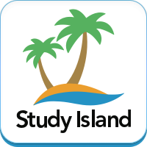  Edmentum  Study Island | Students can practice standard-specific lessons with accompanying game applet following correct answers. | All Disciplines K-8 | Edmentum will offer free home Study Island Subscription.  Study Island at Home  K-12 Work Bundles
INFOhio   | Ohio’s PreK-12 Digital Library | All Disciplines PreK - 12 | https://www.infohio.org/
iReady   | Provides online lessons based on students’ skill levels. Students are already working in their pathway.  Printable packets are also available through the link. | Reading and Math K-3 | https://www.curriculumassociates.com/supporting-students-away-from-school  https://i-readycentral.com/articles/engaging-families/
NewsELA   | Provides online and printable lessons at 5 reading levels. Content articles are available across disciplines. Full program unlocked through the end of the school year. | All Disciplines 2-12 | Suite Overview  Remote Teaching Toolkit
*ODE Ohio State Tests & EOC Exam Practice Site   | Welcome to the Practice Test site. You can use this site to take sample online tests. Some questions will require you to select one answer; others may require you to type a short answer, move objects, or complete another type of open-ended task. | Elem - Middle - High | https://login9.cloud1.tds.airast.org/student/V388/Pages/LoginShell.aspx?c=Ohio_PT
*Scholastic  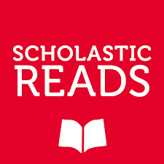 | Students will have access to approximately three hours of learning opportunities per day, including projects based on exciting articles and stories, virtual field trips, reading and geography challenges, and more. | Reading PreK-9+ | https://classroommagazines.scholastic.com/support/learnathome.html
*Storyline Online   | The SAG-AFTRA Foundation’s award-winning children’s literacy website, Storyline Online, streams videos featuring celebrated actors reading children’s books alongside creatively produced illustrations. Readers include Viola Davis, Chris Pine, Lily Tomlin, Kevin Costner, Annette Bening, James Earl Jones, Betty White and dozens more. | Reading PreK-5 | https://www.storylineonline.net/
Typing Agent   | A personalized learning experience for typing students. | K-12 | https://typingagent.com/#typing_agent_features
*ESL Division  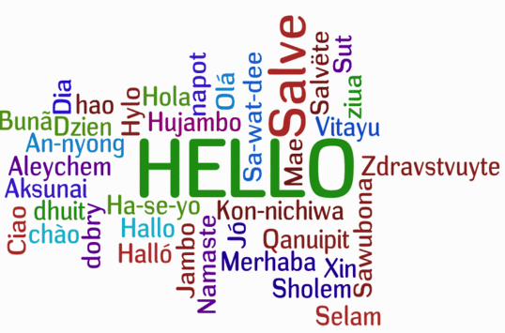 | A variety of activities for students who are learning English | All ESL Students K-12 | https://www.ccsoh.us/domain/213
*Gifted & Talented Division   | A variety of sites and programs for students who are gifted | All GT Students K-12 | https://www.ccsoh.us/site/Default.aspx?PageID=4799
*Special Education & Student Support Services   | Resources from the Department of Special Education & Student Support Services. These are printable or online resources through CCS Google | K-12 | https://docs.google.com/document/d/1Pf9MvHiXG9fJaoQ_yfkAeQpISbhNirl5Vbzxz-kV8K8/edit?usp=sharing

*Access through listed website

If you are in need of WIFI access see the links below for additional information:
https://internetessentials.com/
https://www.internetessentials.com/covid19

